EUR-Vinca-Early Female

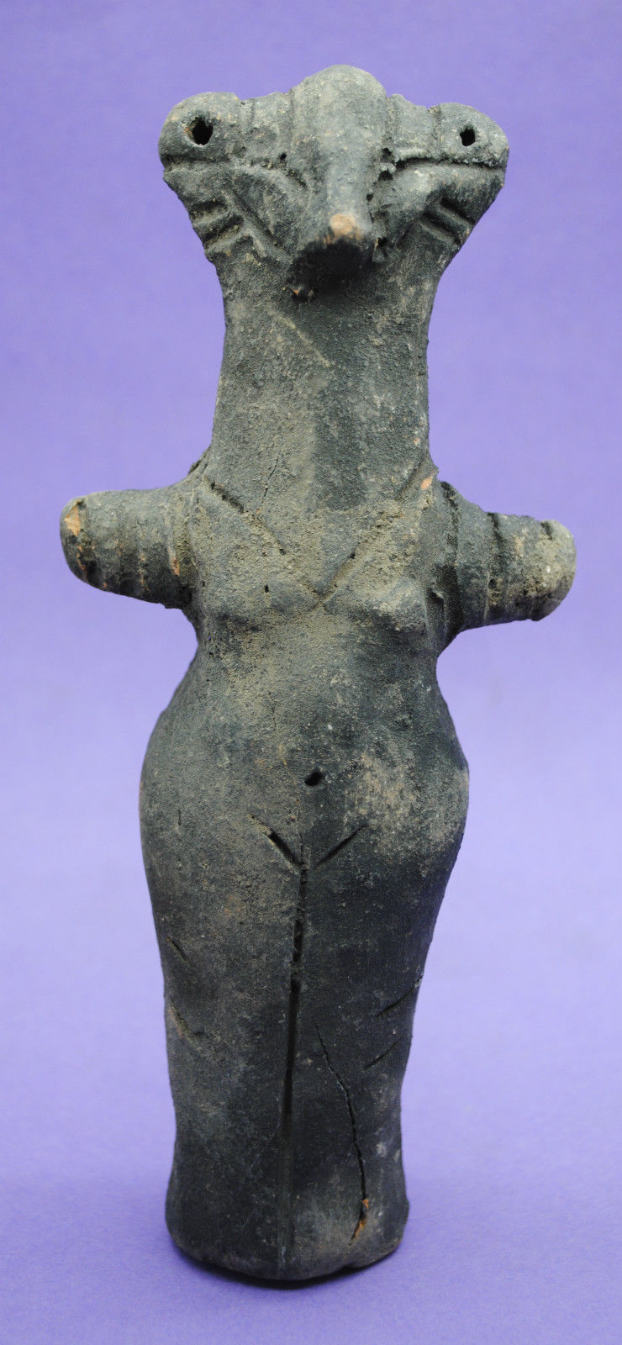

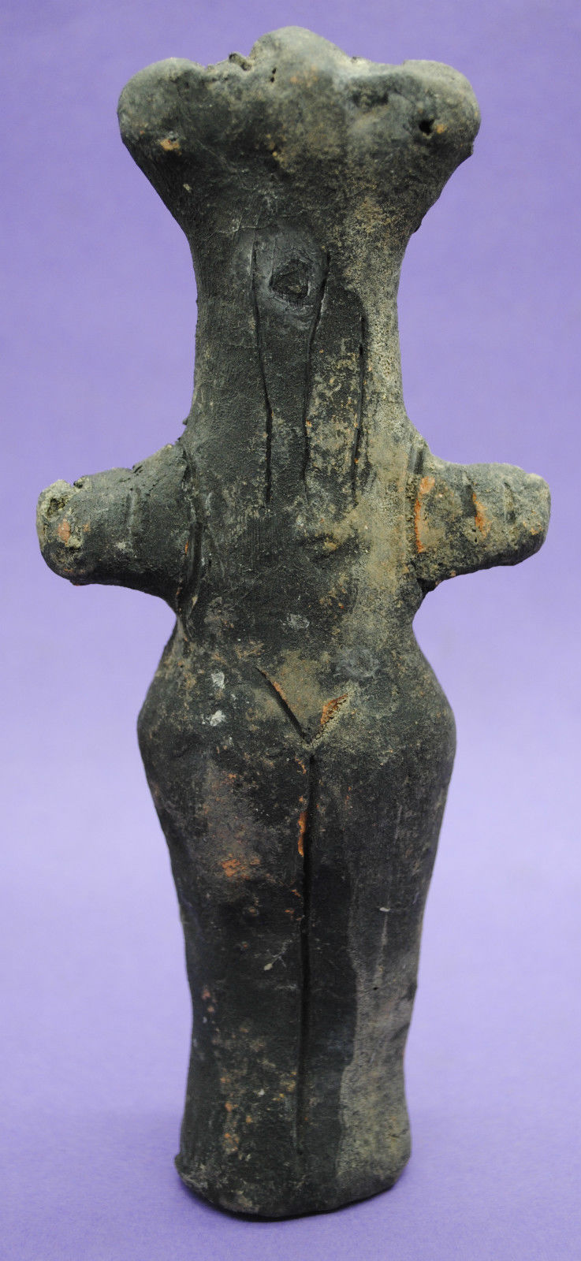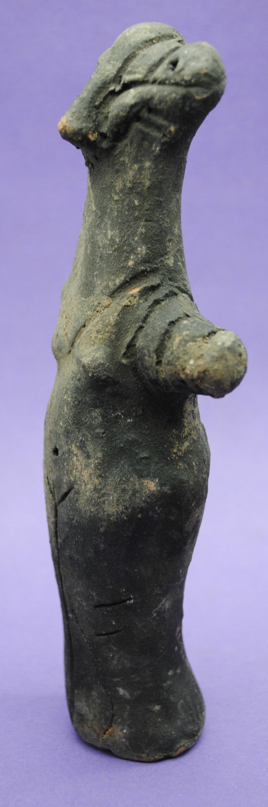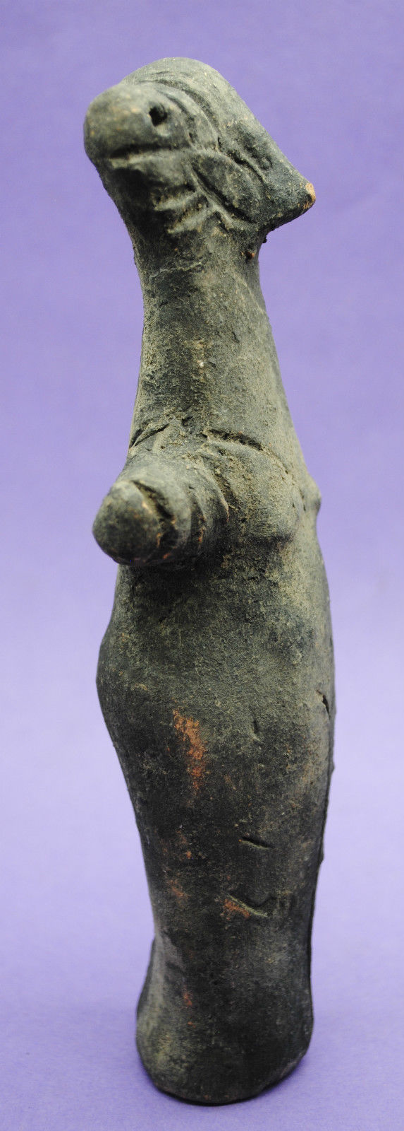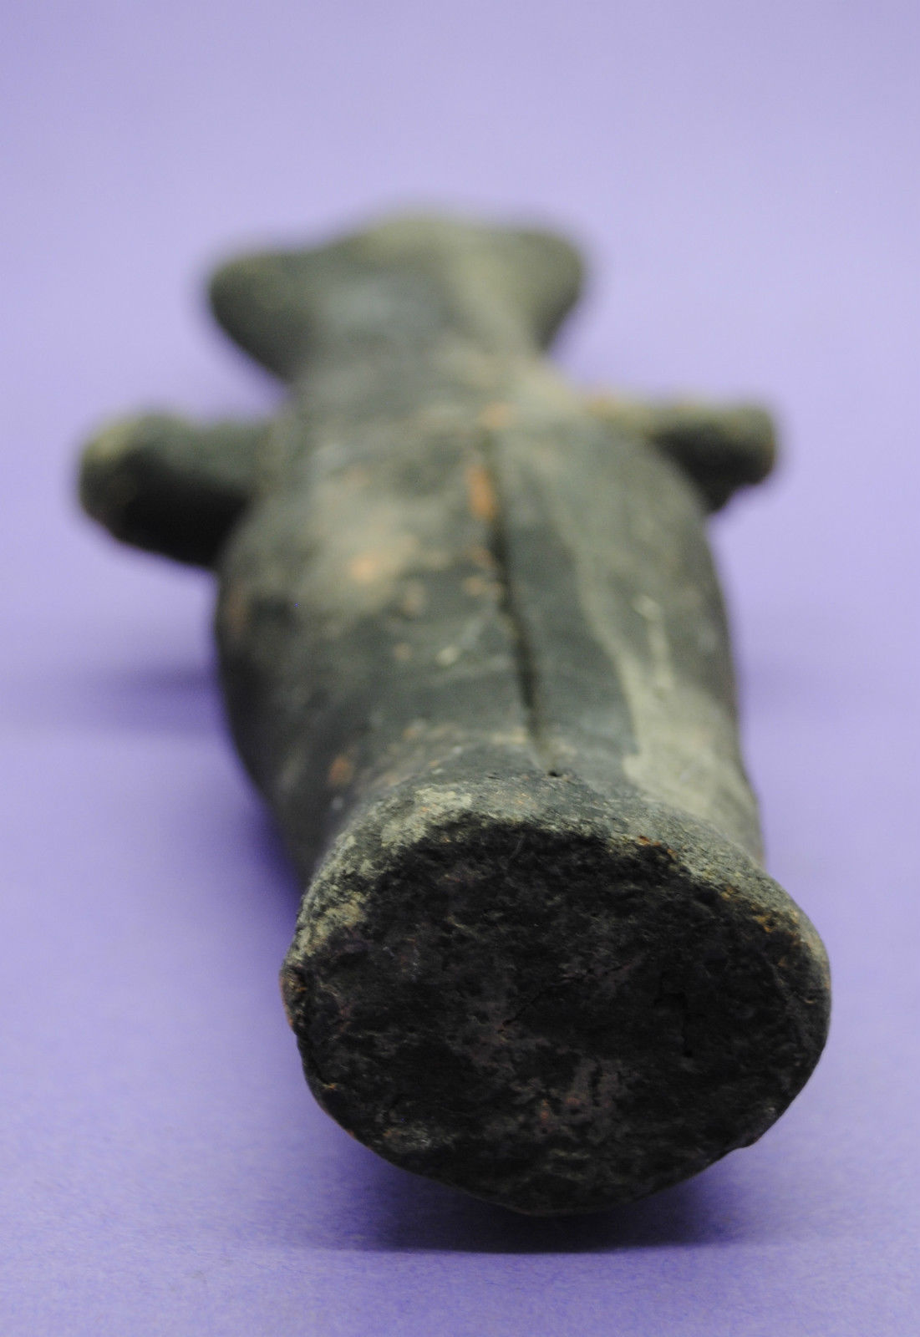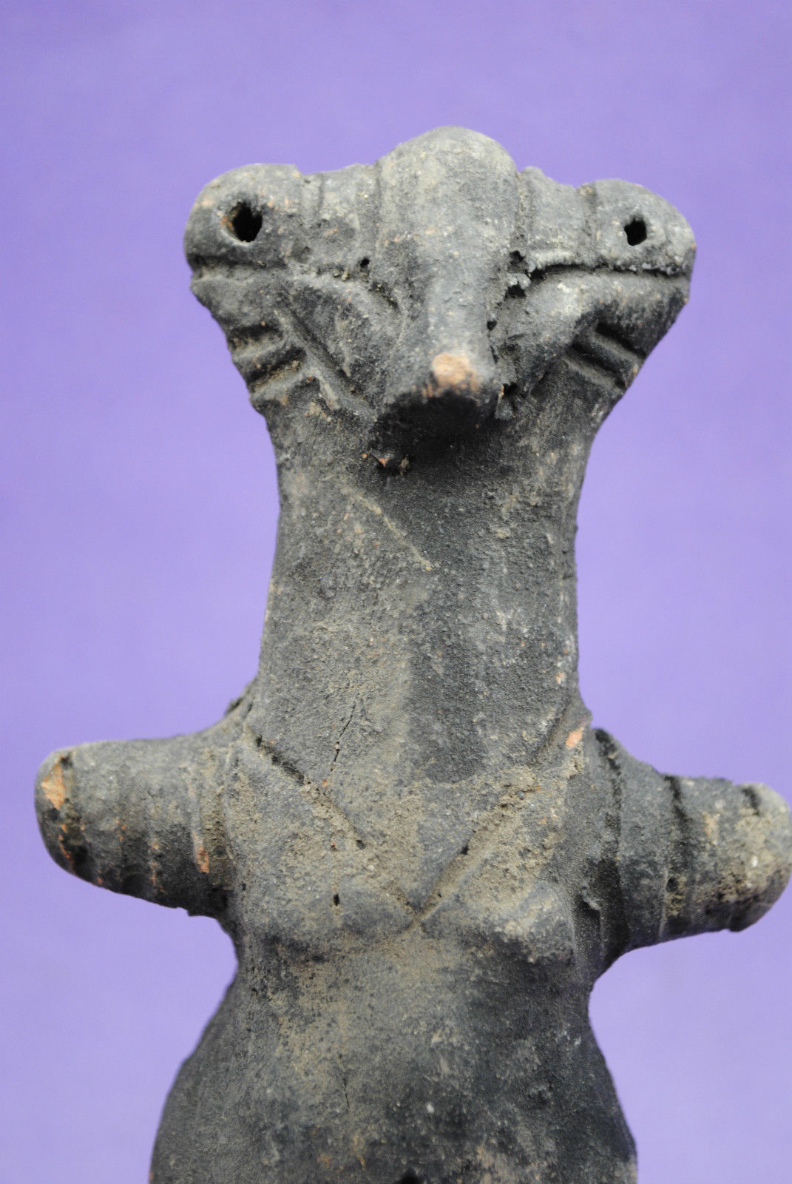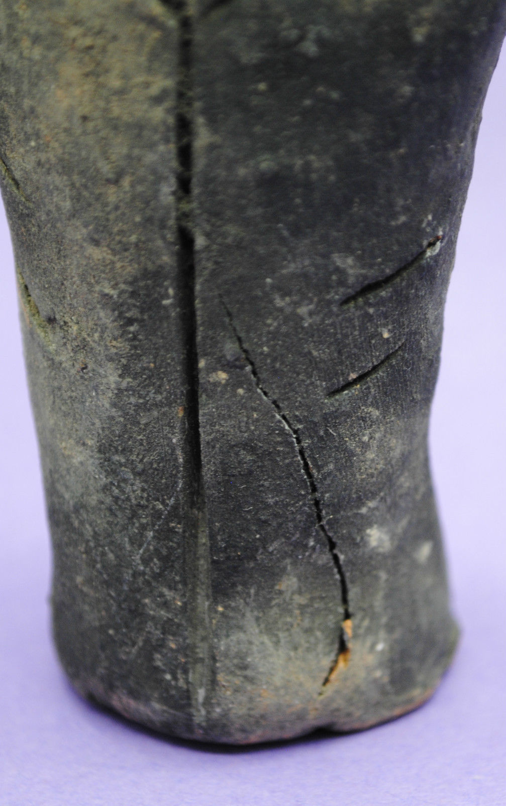

# Order details

Printer friendly page

## Sales order

Sold by [anglo-antiques](http://myworld.ebay.com/anglo-antiques) ( [412](http://feedback.ebay.com/ws/eBayISAPI.dll?ViewFeedback&userid=anglo-antiques) )

+ Show additional actions

### Delivery package 1 of 1

Estimated delivery Monday, Jul 18, 2016 -Monday, Jul 25, 2016

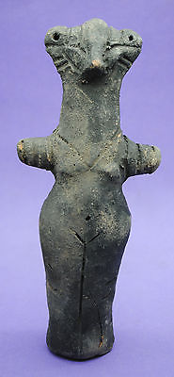

#### [PREHISTORIC ANCIENT VINCA CULTURE ANTHROMORPHIC FIGURINE 5000 BC](http://www.ebay.com/itm/262477151670)

|  |  |
| --- | --- |
| **Item price** | $220.83 |
| **Quantity** | 1 |
| **Item number** | 262477151670 |
| **Shipping service** | Royal Mail International Tracked |

## Shipping address

Ralph J Coffman Jr

149 Atlantic Ave

Swampscott MA 01907-2427

United States

## Order total

|  |  |
| --- | --- |
| **Subtotal** | $220.83 |
| **Shipping** | Free |

**Total**

$220.83

*Pricing based on current conversion rates

[View PayPal transaction](http://payments.ebay.com/ws/eBayISAPI.dll?UnifiedCheckoutSummaryRedirect2PP&itemid=262477151670&transId=1850120314016&buyerorseller=0)

Order placed on

Tuesday, Jul 12, 2016

Payment method

PayPal

Payment date

Tuesday, Jul 12, 2016